**GYM CUSTOMER CHURN ANALYSIS & RETENTION INSIGHT**



**BY**

**RAMYA SRI M**

**GYM CUSTOMER CHURN ANALYSIS & RETENTION INSIGHT**

**EXECUTIVE SUMMARY:**

This analysis evaluates customer churn patterns in a fitness centre with **4,000 members**. The overall **churn rate is 26.53%**, meaning roughly **1 in 4 customers leave**, while the retention rate is 73.48%. The **average customer lifetime is only 3.72 months**, highlighting a challenge in keeping members engaged long-term.

Key drivers of churn include **younger age groups, short contract periods, low engagement, and lack of referrals/social connections**. On the other hand, **long-term contracts, high engagement, group visits, and referrals** strongly improve retention.

**KPI OVERVIEW:**

* **Total Customers:** 4,000
* **Churn Rate:** 26.53%
* **Retention Rate:** 73.48%
* **Average Lifetime:** 3.72 months

**INSIGHTS BY DIMENSION:**

* **Demographics:**
* **Age Group:**
  + Extremely high churn among younger customers: **0–15 yrs: 75%**, **15–20 yrs: 66.11%**, **20–25 yrs: 36.02%**.
  + Much lower churn in older groups: **25–30 yrs: 11.77%**, **30–35 yrs: 2.13%**.  
    👉 **Interpretation:** Younger customers are less consistent, possibly due to shifting priorities or lack of motivation.
* **Gender:**
  + **Male (26.56%) vs Female (26.49%)** → Negligible difference.
* **Partner Influence:**
  + **With partner: 19.36% churn** vs **No partner: 33.32% churn**.  
    👉 Having a partner is a strong retention factor.
* **Contract Period & Location:**
* **Contract Length Impact:**
  + **1-month contracts → 42.32% churn (highest risk)**.
  + **6-month contracts → 12.48% churn**.
  + **12-month contracts → only 2.40% churn (most loyal)**.  
    👉 Long contracts act as a natural lock-in for retention.
* **Near Location Effect:**
  + **Near gym: 24.11% churn** vs **Far: 39.74% churn**.  
    👉 Distance is a strong predictor of churn.

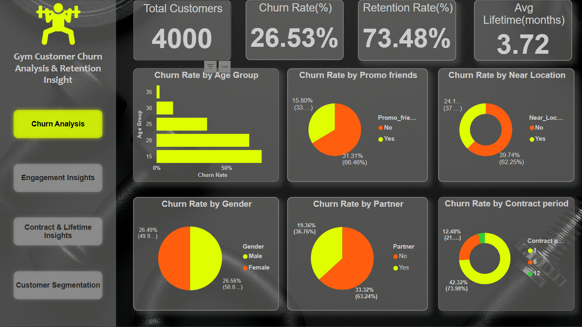

* **Engagement & Spending:**
* **Group Visits:**
  + No group visits → **33.01% churn**.
  + With group visits → **17.28% churn**.
* **Class Frequency:**
  + Overall: **1.88 classes/month**, Current month: **1.77 classes/month** → Declining trend.
* **Engagement Levels:**
  + Low engagement → **32.05% churn**.
  + High engagement → **25.93% churn**.
* **Spending Behavior:**
  + Low spenders → **33.78% churn**.
  + High spenders → **18.02% churn**.

👉 Members who spend more and engage socially are less likely to leave.

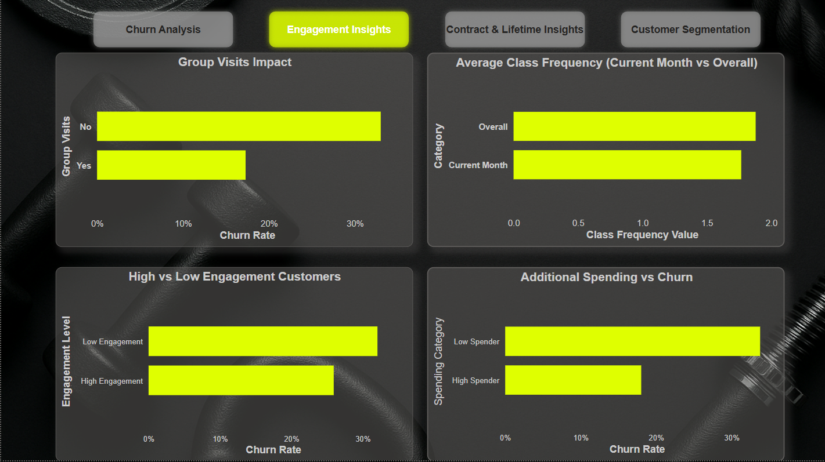

* **Contract & Lifetime Trends:**
* **Lifetime vs Churn:**
  + Early exits are common: **82.75% churn at month 0**, 49% at month 1.
  + After 3 months, churn drops significantly.  
    👉 Customers who stay beyond 3 months are much more likely to continue.
* **Retention by Months to End Contract:**
  + Strong retention during 9–12 months (>97%).
  + Drop in retention when contract end approaches (**~58% churn in last month**).

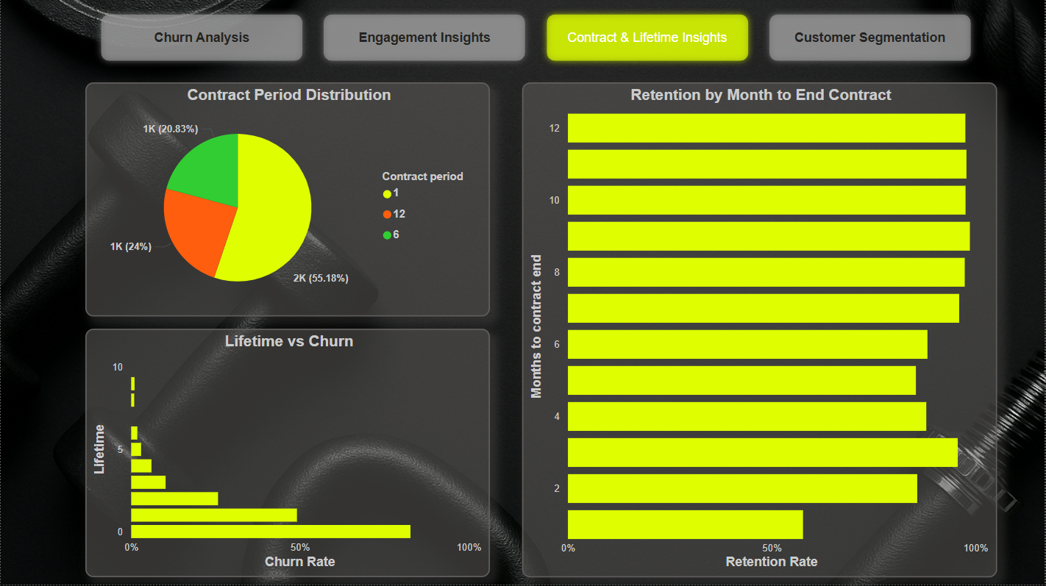

* **Segmentation Insights:**
* **Age + Engagement:**
  + Under 25s churn heavily regardless of engagement (~65–69%).
  + Ages 25–39 with high engagement churn much less (**22.76% vs 28%**).
* **Location + Contract Length:**
  + Short-term contracts + far location → **51.25% churn (highest risk)**.
  + Long-term contracts + near gym → **2.23% churn (lowest risk)**.
* **Referral + Group Visits:**
  + No referral & no group → **37.29% churn**.
  + Referred + group visit → **10.68% churn (best retention group)**.

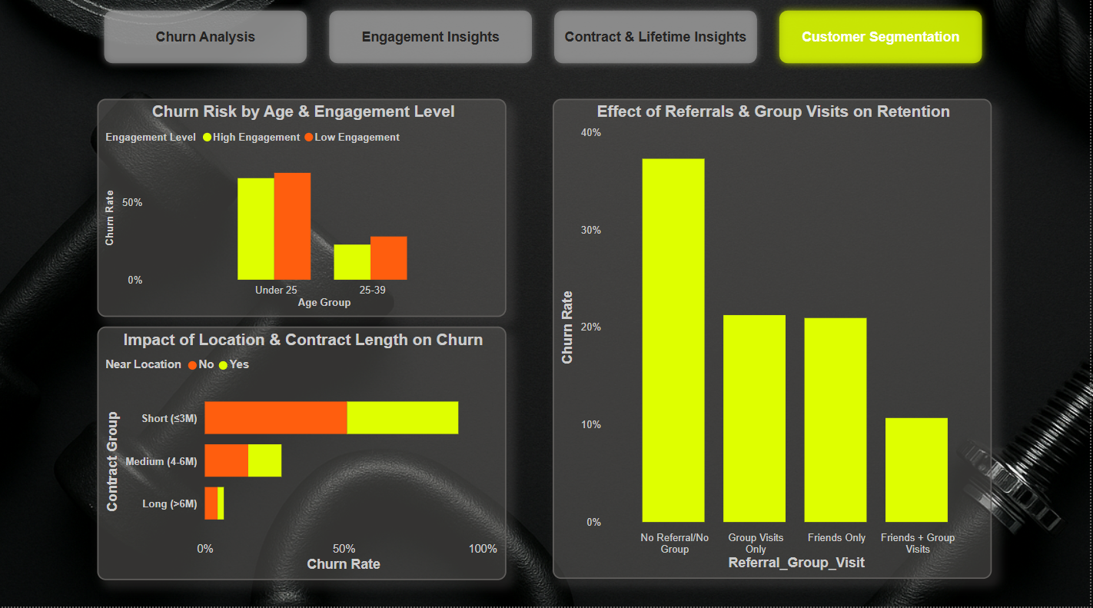

**KEY TAKEAWAYS:**

* **Younger customers** (<25 yrs) are the most vulnerable group.
* **Short contracts and far location** lead to highest churn risk.
* **Social factors** (referrals, partners, group visits) greatly improve loyalty.
* **High spenders and engaged members** are more likely to stay.
* **Critical period is first 3 months** — most customers leave early.

**RECOMMENDATIONS:**

✅ **Promote longer contracts (6–12 months)** with discounts to reduce churn.  
✅ **Targeted retention programs** for young members (0–25 yrs) such as challenges, gamification, or youth offers.  
✅ **Encourage referrals & group workouts** through incentives (buddy passes, referral bonuses).  
✅ **Focus on early engagement** (first 3 months) with on boarding programs, free trial classes, and follow-ups.  
✅ **Personalized offers for low spenders** to push add-ons and increase commitment.  
✅ **Flexible options for far-location members**, like hybrid memberships (online + gym).